**Constrain checklist**

1. Every default char field should not contain more than 30 character
2. Email filed should contain email format
3. Website field should contain website name format
4. Address field should not contain more than 30 character
5. Active check box should be checked
6. XSS command and sql injection should not execute while submitting a form
7. Warning message should be user friendly and eye catchy
8. Button contain text that text should be related with button activity for example: Currently image upload button contain text “Create” which is not right
9. Tooltip need for button action for example:

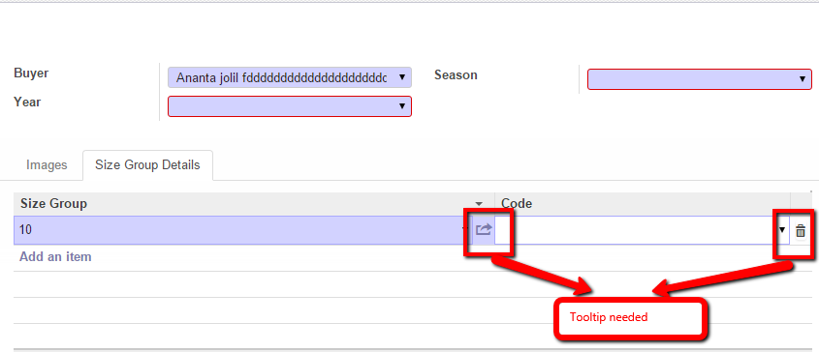

1. Error message should be user friendly and eye catchy on the other hand technical error message should be in small font and should under user friendly error message
2. Error message and warning message should be in middle.
3. Field which will contain number (ex: Quantity, Price) should not negative value
4. UI should not break for any browser
5. Date field should focus on current date
6. Every field should be blank by default (Not for all cases)
7. Special character is not applicable for Char field
8. Always try to follow Odoo form design and concept
9. Check Inconsistency for same type of field
10. All label values should be Title case